For Hire Drivers - Income

For-Hire Drivers report earnings on Schedule C
- Uber/Lyft/etc. business code: 485990 All other transit and ground passenger transportation
- Grubhub/DoorDash/etc. business code: 492000 Couriers and messenger on Schedule C
- Loss on Schedule C is out of scope
- Review documents during interview for scope
- Taxpayers determine their income, mileage and other expenses
Income Reporting Documents
- Statement from the payer showing income, commissions and fees, mileage, etc.
  - Taxpayer needs to print from his/her online account
- Form 1099-MISC
- Form 1099-K common with Uber/Lyft
  - Payment Card and Third-Party Network Transactions
- May also receive cash (tips for example)

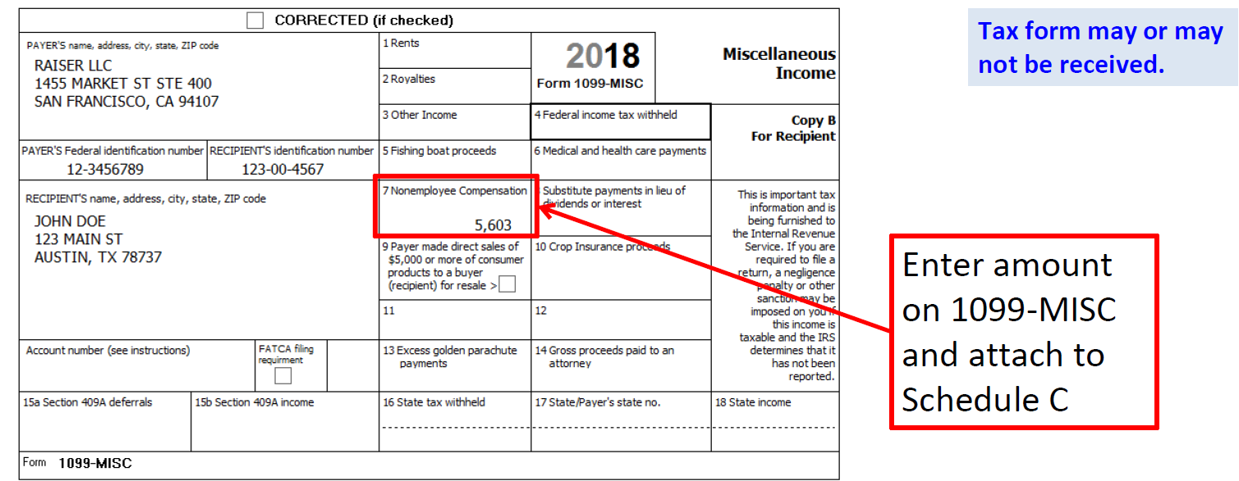

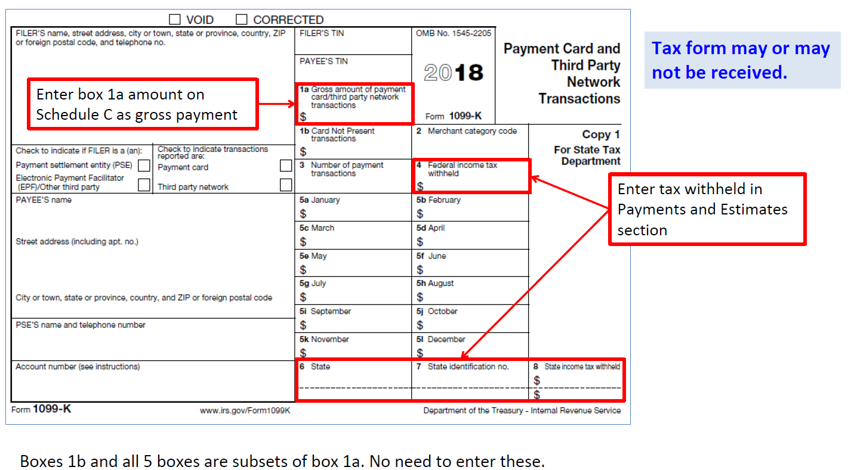
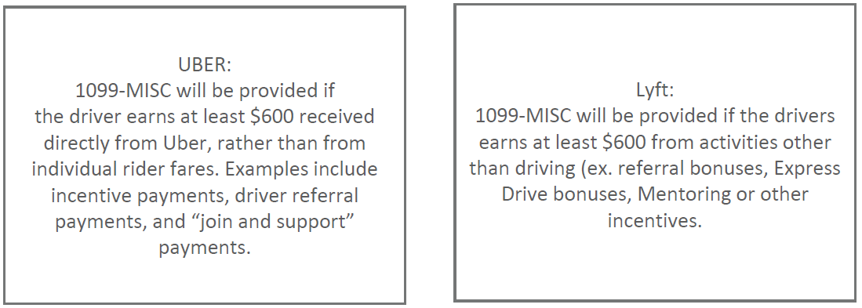

Lyft/Uber – A 1099K will report payments received from riders only if the driver has more than $20,000 in customer payments and provided at least 200 rides or deliveries.
Uber Breakdown of Income and Expenses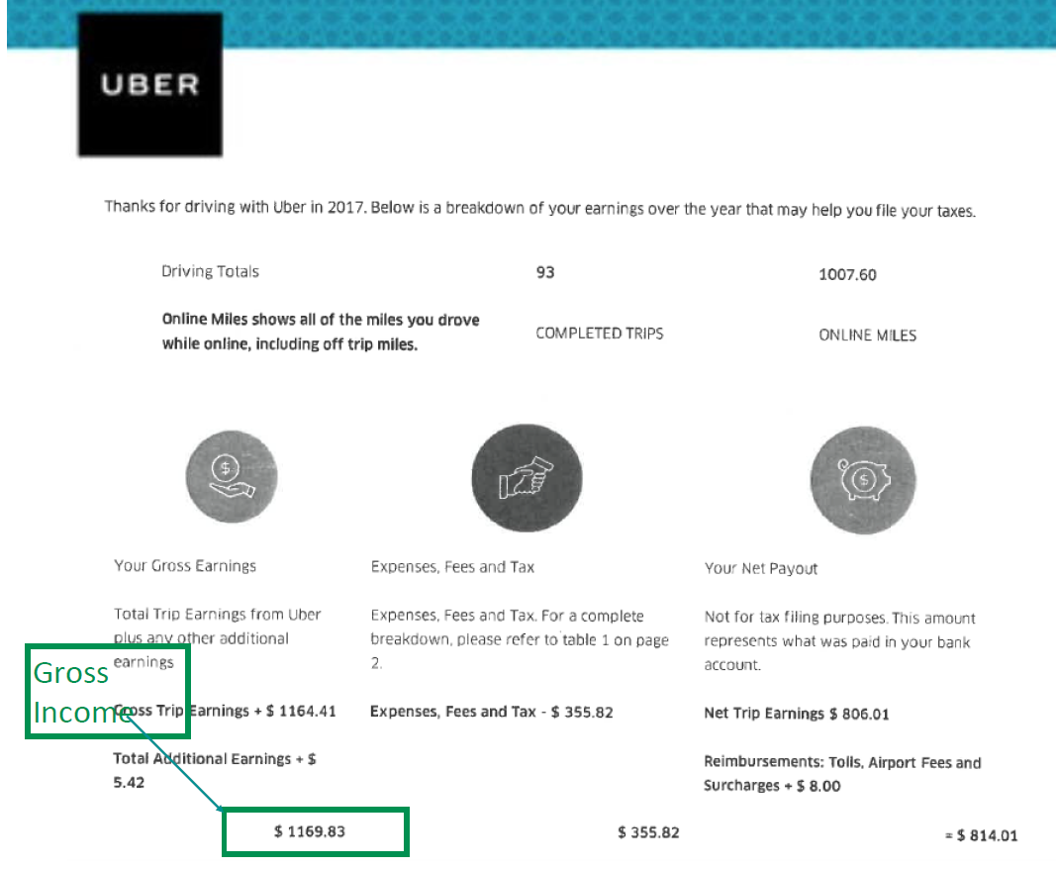

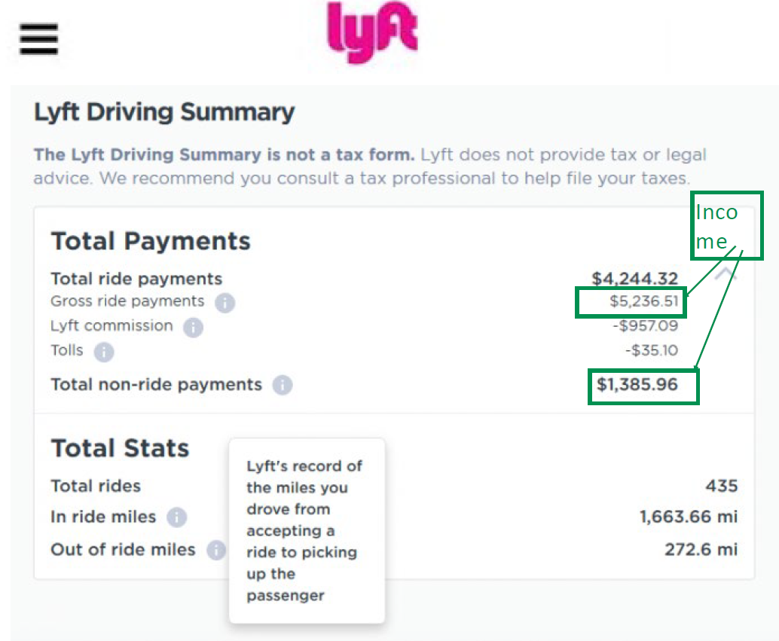

Enter 1099-MISC if provided into TaxSlayer and link to Schedule C
- Income for Uber, Lyft, etc. business code 485990 can be entered on one schedule C
- Income from Grughub,,Doordash, etc business code 492000 can be entered on one Schedule C
- Multiple business codes can not ne entered on one Schedule C

TaxSlayer Entry Screens for Income
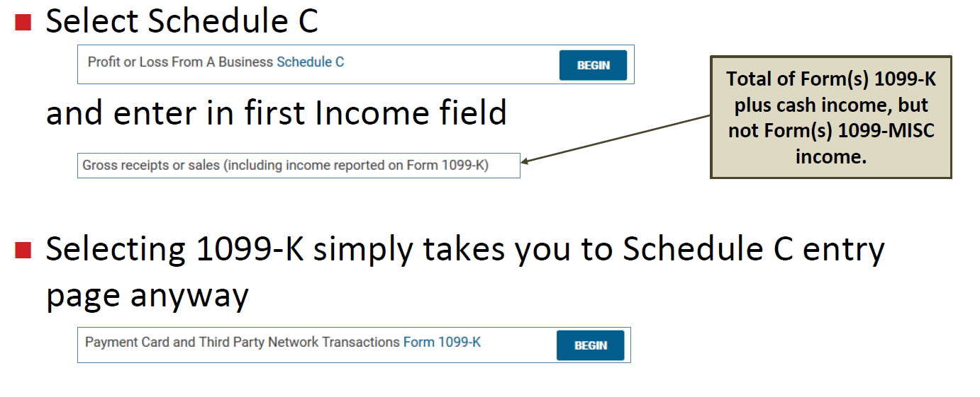

For Hire Drivers – Expenses

Standard mileage rate (54.5¢/mile for 2018) in scope for For-Hire Drivers
- Out of scope if actual vehicle expenses claimed
- First and last ride of day to and from home are nondeductible commuting miles
unless taxpayer claims home office deduction (which is out of scope)

Detailed records essential
- Total mileage – business, commuting and other
- Business expenses
- Business use and purpose

All expenses must be reported – even if result is a net loss (which is out of scope)
Add to standard mileage business portion of
- Tolls: 100% business use when incurred as For-Hire Driver
- Parking: 100% business use when incurred as For-Hire Driver
- Auto loan interest
- Auto personal property taxes (N/A for NJ)

Taxpayer to determine business portion based on miles driven or
other reasonable method when property not 100% business
Example:
• Business miles 4,500 ÷ Total miles 45,000 = 10% business use
• $1,000 interest paid on auto loan in 2018
• $1,000 X 0.10 = $100 deductible auto loan interest on Schedule C

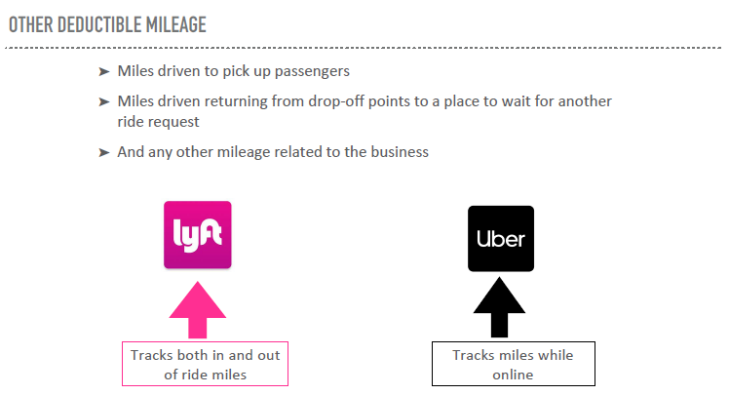
Uber’s Tax Summary has only one mileage number (“Online Miles”). This is the number of miles driven while the app is on. So it will include all allowable miles but also may include non-allowable miles e.g. driving to/from home and personal. Enter as Business Miles the “Online Miles” LESS TP-advised disallowed miles for commuting and personal while in Driver mode in App.
Lyft’s Driver Summary has two mileage numbers. “In ride miles” are those driven with the passenger onboard. “Out of ride miles” are those driven from accepting a ride to picking up the passenger. Enter as Business Miles the In ride Miles PLUS Out of ride Miles LESS TP-advised disallowed miles for commuting and personal mile while in Driver mode in App.

Examples of potentially 100% business use expenses
- Uber/Lyft/Grubhub/etc. fees
- Device subscription fees
- Snacks and water for passengers
- Passenger cell phone accessories, such as chargers and cables
- Mileage tracking software
- Airport fees
- Business license
- Ride sharing insurance
- Dash camera
Examples of ratable business-use expenses
- Car washes
- Cell phone and mount
- Flashlights and flares
- First aid kit
- Road-side assistance plans
- Dash camera

Were to find Income & Tax Information
